**2022.01.27 Not So Simple Pendulum**

**Start Time:** circa 09.00

**Second Start Time:** circa 14.00

Aim

An experiment was carried out to explore two main ideas in Physics from the simplicity of a pendulum - these concern exploring amplitude dependence on the pendulum’s period, and the mass dependence, by utilising pendulum bobs of identical volume, but made from differing materials. With the aid of a digital camera (as opposed to a stopwatch as was previously done in the intro cycle), in the first experiment, we analysed our video data through the Python libraries pillow and opencv, curve-fitted it to a sinusoidial curve obtaining its period, then plotted this data against its angular amplitude. In the second experiment, using known values for density of the materials tungsten, nylon, aluminium and brass, we attempted to ascertain the mass dependence, through a linear plot.

Background

This experiment demonstrates simple harmonic motion through the use of a pendulum. By considering a pendulum and its oscillations, we can arrive at the following equation:

where, as the diagram below suggests, a bob of mass m, which is attached to a string of length l, making angle θ with the vertical obeys Newton’s Second Law of Motion. Or as summarised below:

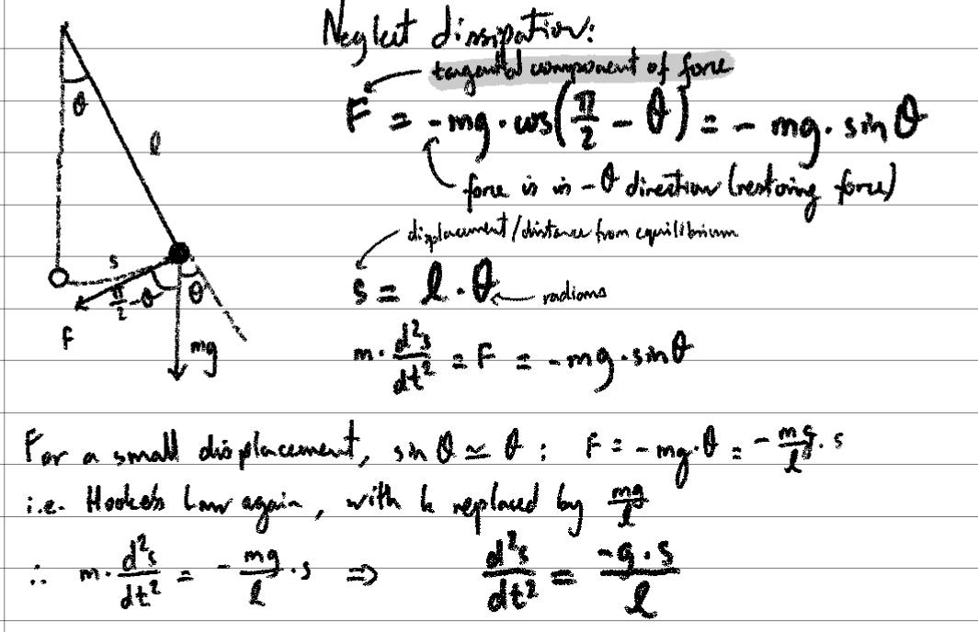

By taking the small angle approximation (first-order Taylor expansion)

we arrive at the conclusion that:

Consequently, it follows from this that:

Rearranging equation 4, we have:

Description of Set-Up, Measurement Strategy, Uncertainties

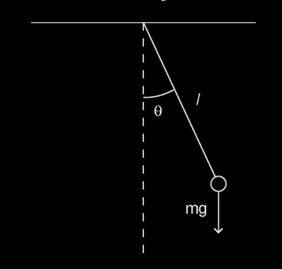

Figure 1: Mangles et. al (ed.), 2021, “Year 1 Laboratory Manual Pendulum”, a diagram of a simple pendulum

Using a brass bob, a pendulum was set up with a length of thread around 30-40cm. This was clamped to a retort stand. A protactor was attached to the clamp where the bob was to measure initial angular displacements, and the string was held perpendicular to this protactor’s angle marks upon release.

N.B: the threaded rod that the bob attaches onto allowing for fine adjustments, but keep fixed.

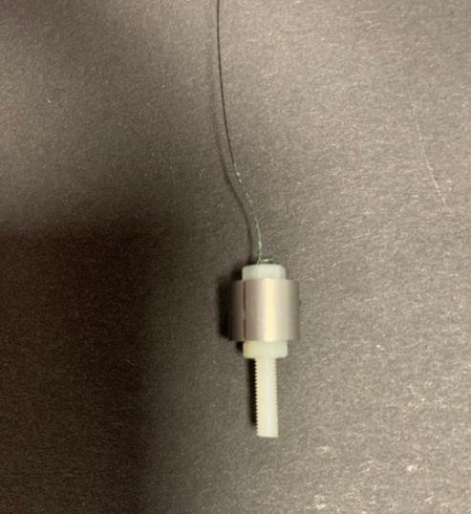

**Picture 1:** an example of the pendulum bob used during the practical

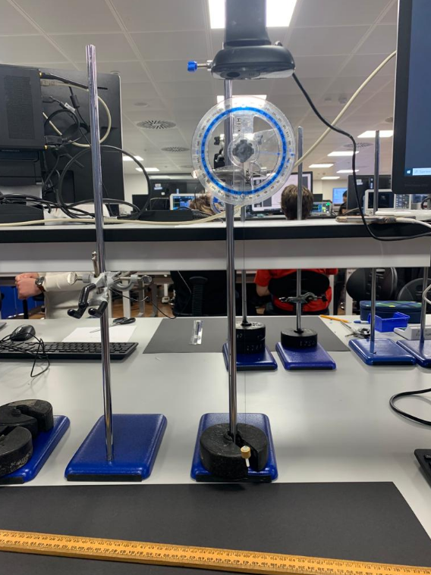

**Picture 2:** experimental setup of pendulum, and recording camera. The camera pictured above could capture recordings at 30 frames per second, and at a maximum screen resolution of 1280 × 720 pixels. In addition to this, picture above were a protractor which was aligned to the normal, a metre rule as well as clamp and retort stand.

We made use of the gridlines that feature in rule of thirds to minimise y-direction displacement by ensuring our oscillations sufficiently lined up with the rule of thirds axes, so the horizontal displacement represented the oscillations of the pendulum as accurately as possible, . Evidently, this proved increasingly difficult for higher angular displacements as the pendulum was more prone to swaying side to side (in the y-direction).

**Experiment 1:**

From equation 4, we can see that the period of an oscillation should have no time dependence on the amplitude of the pendulum. Consequently, we will investigate whether there is such a dependence. A series of videos were then recorded to measure the period of the pendulum after starting at different amplitudes, and recording the initial amplitude. Using Python code, OpenCV, and pillow libraries (as well as numpy and scipy), a curve fit allowed us to work out what the period was.

*Prediction:*

*(see equation 5 in Data Analysis)*

We expect our values of α and β to both be relatively small as we expect there to be little relationship between the time period and amplitude whilst the small angle approximation holds. Thus the quadratic curve will only start taking off beyond angular displacements of around 20°. Even still, the small angle approximation (first order Taylor expansion) is accurate with less than 1 percent error until about 14 degrees, so, we hope our pendulum formula should hold up (!) As β represents the second-order constant, I expect that it will be smaller still than our value for α.

**Experiment 2:**

When we equate the left and right sides, in equation 1, we are using Newton’s Second Law and equating this equation to Newton’s Law of Gravitation, which equates the inertial mass with gravitational mass. Whilst we suppose this is the same, this is an active area of research and is open to experimental test, but the two are known to be equivalent to with a factor of 1 in 10¹².

Using identically-sized pendulums of tungsten, brass, aluminium and nylon, we recorded the periods of each, similarly.

*Prediction*

***(****see equation 6 in Data Analysis)*

We therefore expect our value of k to be very small, close to 0. This is since we assume for there to be very little dependence (if there should be any) of the ratio of gravitational mass to inertial mass on the density of the material used in the pendulum bob. Expect a negative correlation, so a negative k.

|  |  |
| --- | --- |
| **material** | **density / g.cm¯³** |
| nylon | 1.13 |
| aluminium | 2.7 |
| brass | 8.45 |
| tungsten | 19.3 |

**Table 1**: Material densities of pendulum bobs provided

**Uncertainty Analysis**

**Experiment 1:**

*AIM:* Record enough periods to reduce uncertainty of period, within at least 1%

|  |  |  |
| --- | --- | --- |
| **angular displacement, θ / degrees** | **± 2°**  **random /**  **systematic** | For this experiment, it made sense not to include any increments of angular displacement any smaller than the 5 degrees that we prescribed as a result of the following uncertainties:  Already limiting our precision is the inherent uncertainty originating from the resolution of the protractor (±1°). We also factored in the parallax error from observing the readings off the protractor, and we thought it would be unreasonable to select increments of any smaller than 5° for our readings.  This was minimised through taking in total, over 60 videos which were then subsequently analysed in bulk, and the average at each angular displacement obtained. |
| **length of string, L / metres** | **± 0.01m**  **random** | In order to obtain more accurate measurements whilst measuring the length of string, we didn’t use the ends of each metre rule on which the readings had worn away a bit, but instead made use of alternative portions of the ruler. |
| **ThorLabs camera recorded times, t / seconds** | **± 0.017s**  **random** | We found the camera to have a precision of 30 frames per second, thus the smallest time increment from the camera would be 1/30 = 0.033 seconds (recurring).  Following standard deviation calculations, this yields an uncertainty of 0.017 seconds in each captured frame.  This source of uncertainty (relative to the variations over which our data changed) was a large contributor to uncertainty. It was incorporated through the sigma parameter in scipy’s curvefit.  The limitations of the camera were also minimised through the built in flicker reduction feature of the camera, set to 50Hz, in order to ensure the camera |

**Experiment 2:**

*AIM:* Systematic errors - try to keep length constant by swapping different bobs onto same holder

|  |  |  |
| --- | --- | --- |
| **ThorLabs camera recorded times, t / seconds** | **See above** |  |
| **length of string, L / metres** | **See above** |  |
| **Uncertainty that occurred whilst changing material of the pendulum bob** | **random** | This was minimised by maintaining the same experimental set up as much as possible, merely swapping out the bob, and not the bob holder. |
| **Uncertainty in the density of the materials used** | **systematic** | The pendulum bob holder was made of plastic and hence a different material to the one of the bobs and may have affected measurements slightly. However, this would affect each equally (assuming the pendulum bobs are of equal volume) and as we are trying to obtain a gradient from a graph, a systematic shift would not affect the gradient. |

**Data Analysis**

Evidentally, uncertainties arose from the actual procedures applied in Python to our videos. The vast majority of these are automatically quantified by the covariance matrices which they output, and their standard deviations formed part of the subsequent inputs for later functions with the sigma parameter.

For instance, an example of how this was performed can be seen below:

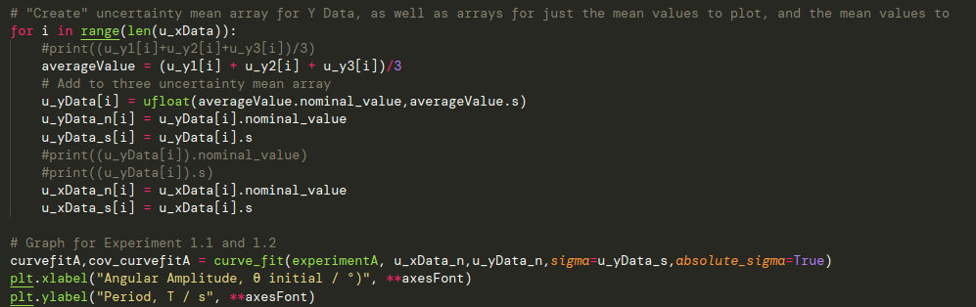

|  |  |  |
| --- | --- | --- |
| **OpenCV**  **cv.threshold Function** | **random** | The way the code provided functioned was through converting RGB into grayscale and then working out the average position of the “light colours” that surpassed a certain threshold specified by this function. Consequently, any other lightly coloured object on screen would complete scramble data.  To minimise this error, FFMPEG, a command-line tool was used to crop the images solely to the path of the oscillation, to remove all other distractions that might have been picked up by the camera. |

Data Analysis

The following graphs obtained below were run locally on VSCode instead of using the Google Colab, since this was more efficient in processing all the videos in bulk (there were many).

**Experiment 1:** Data Series 1

This represents our original set of data. When taking our data, the protractor obscured the camera so we used so FFMPEG had to used in order to further crop our video, and our original videos in Data Series 1 were too long (25 seconds), so they were cropped into 5 second clips. The results are shown below:

*Profile Plots:*

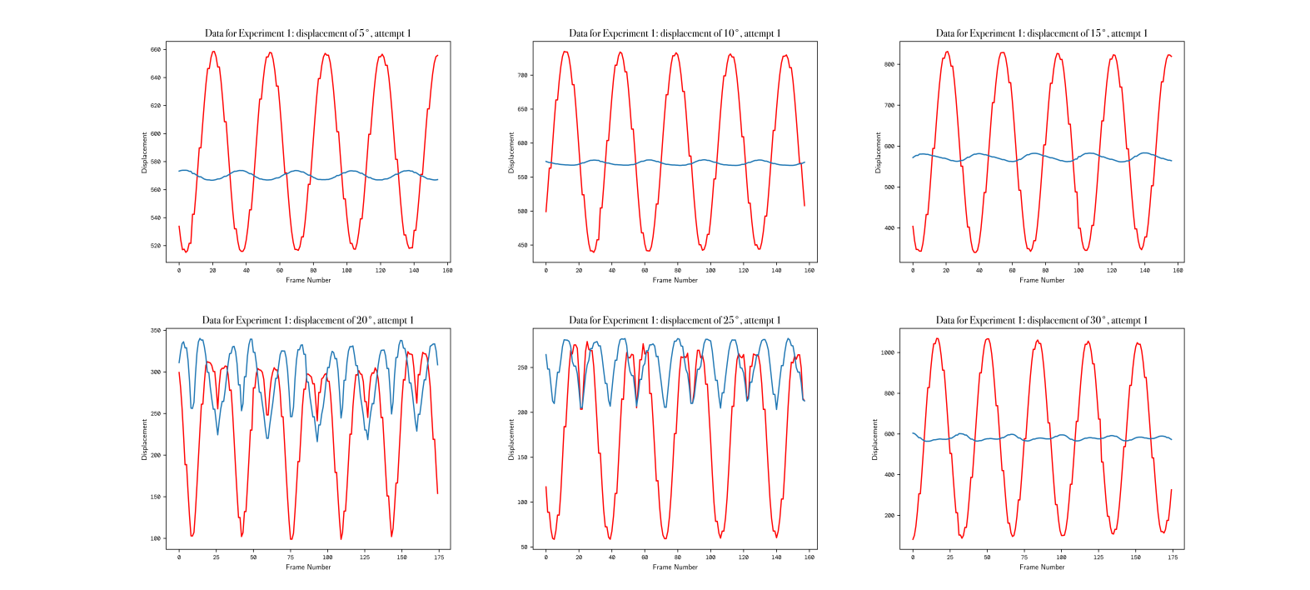

**Figure 2:** The displacements of the pendulum in the **x** *(red)* and **y** *(blue)* direction. Clockwise from top-left: displacement of 5°, displacement of 10°, displacement of 15°, displacement of 20°, displacement of 25°, displacement of 30° The x-axis of the profile plots represent frame number, whereas, the y-axis represents the displacement in arbitrary units. The unit used was irrelevant as the data being taken related to the period of the various sine waves.

*Curve Fits:*

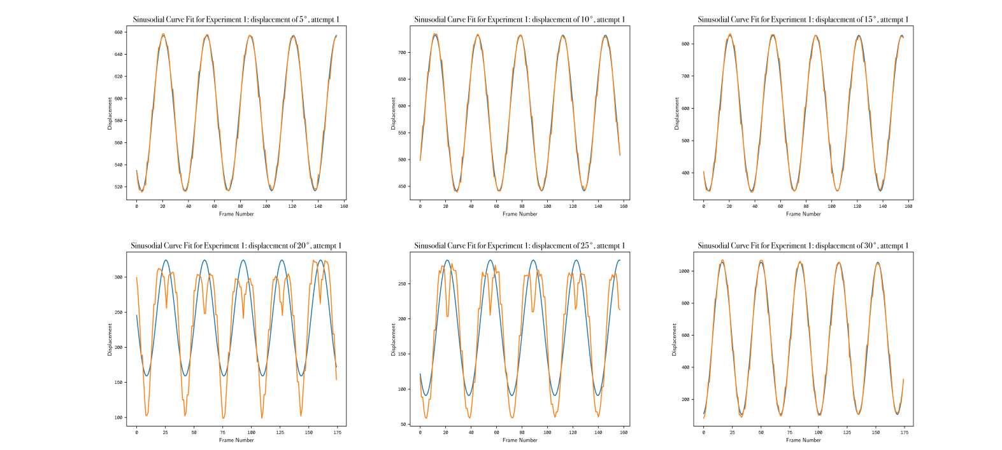

**Figure 3:** The curve fits obtained from the sine fits, using Scipy’s Curvefit function, to the x-displacement. Clockwise from top-left: displacement of 5°, displacement of 10°, displacement of 15°, displacement of 20°, displacement of 25°, displacement of 30°. Similarly, the x-axis of the curve plots denotes the frame number. The curve fits for 20° and 25° were evidently less tidy and this is reflected in the final plots obtained (see **Figure 8** for further discussion).

**Experiment 1:** Data Series 2

This data, unlike Data Series 1, was recorded later once the experiment was recreated, so we ensured to keep the data from the two series separate rather than join them together to make one plot. This data series improved upon Data Series 1 as we made use of the built-in crosshair feature on Windows 10’s Camera app (rule of thirds), and this consequently resulted in great reduction in the forwards and backwards (unwanted) movement of the pendulum, as opposed to the intended side-to-side motion. Additionally, the video clips were taking in too low ambient lighting, so again FFMPEG had to be used to increase the gamma brightness of all the videos (in bulk). This allowed for the data to be processed.

This is shown in the graphs by the **BLUE** curve, whereas the **RED** represents the side to side displacement. However, at largest displacements, it can be evidently seen that the side to side movement was harder to control and consequently increased.

*Profile Plots:*

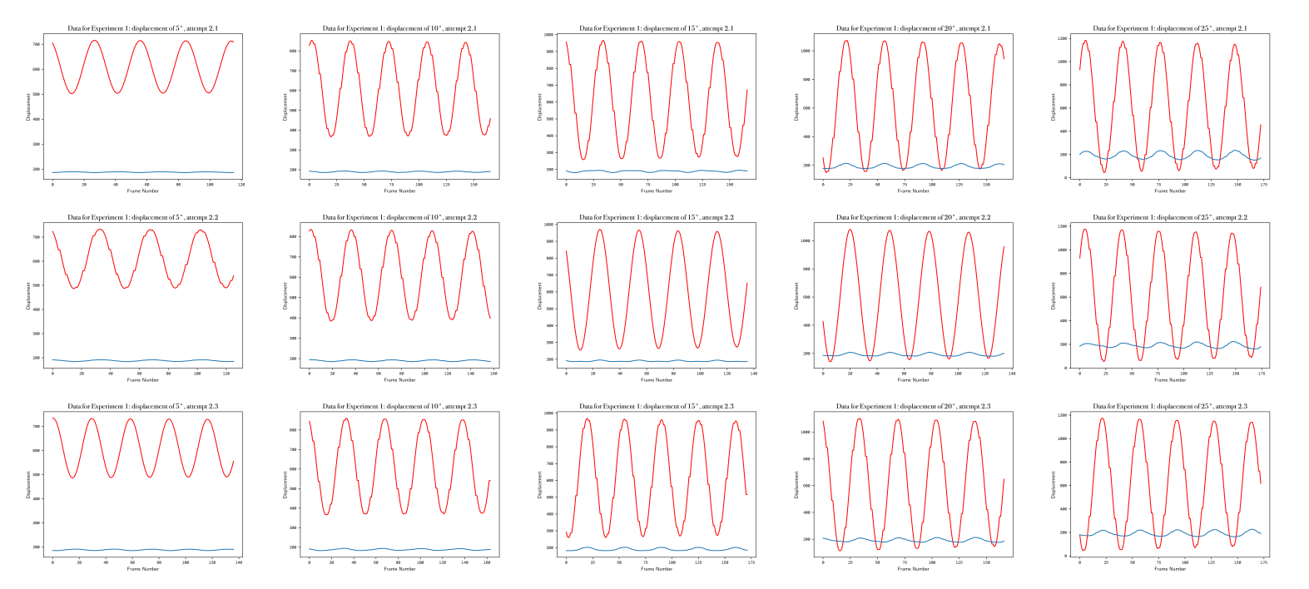

**Figure 4:** The displacements of the pendulum in the **x** *(red)* and **y** *(blue)* direction. The columns represent 3 attempts for each of the various angular displacements (left to right): displacement of 5°, displacement of 10°, displacement of 15°, displacement of 20°, displacement of 25°.

*Curve Fits:*

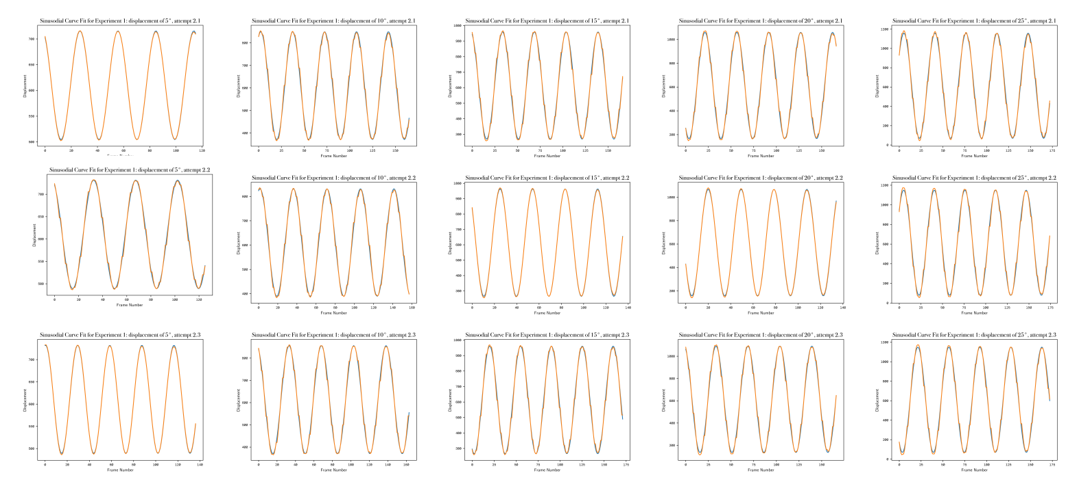

**Figure 5:** The curve fits to the x-displacement. The columns represent 3 attempts for each of the various angular displacements (left to right): displacement of 5°, displacement of 10°, displacement of 15°, displacement of 20°, displacement of 25°.

**Experiment 2:**

*Profile Plots:*

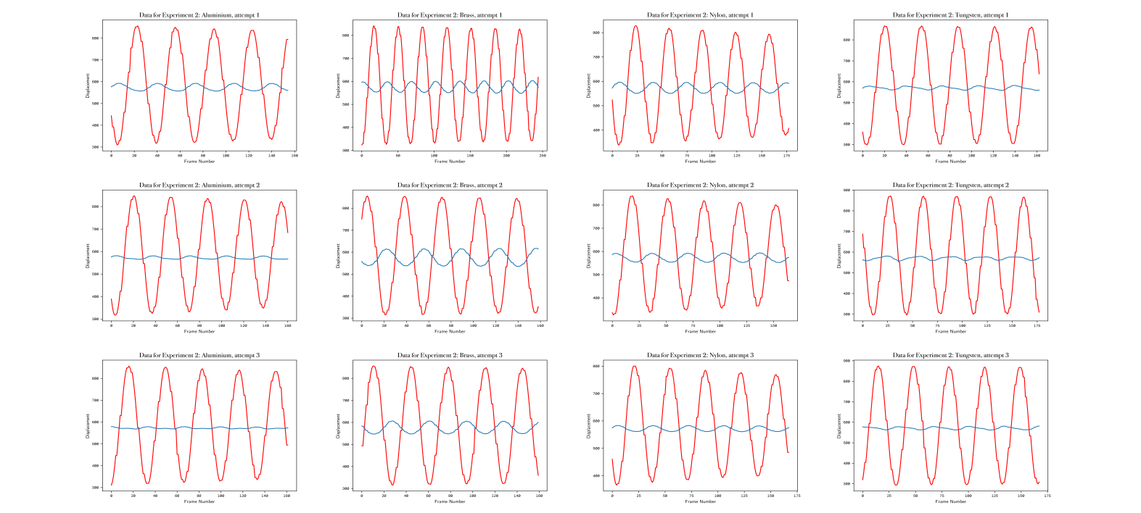

**Figure 6:** The displacements of the pendulum for different pendulum bobs (left to right): aluminium, brass, nylon and tungsten.

*Curve Fits:*

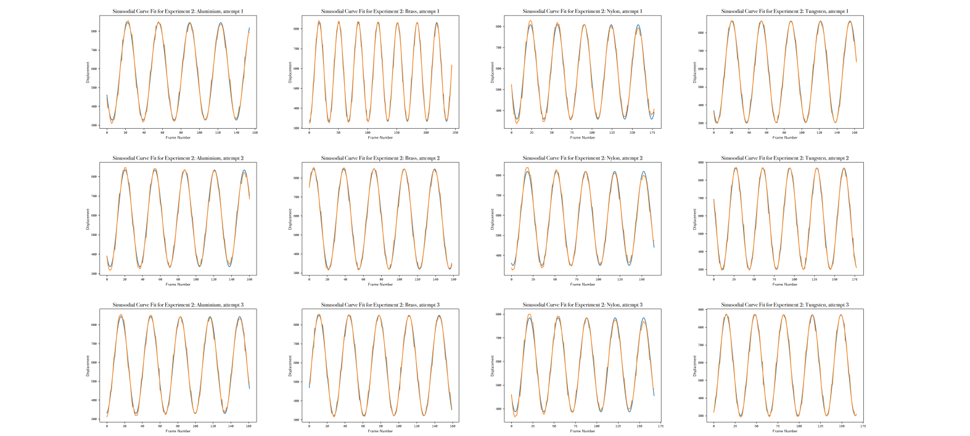

**Figure 7:** The (very tight and snug, almost unseen on this diagram due to the extremely tight fitting) curve fits of the x-displacement of the pendulum for different pendulum bobs (left to right): aluminium, brass, nylon and tungsten. Note, in the first row second column, (i.e. Brass, Attempt 1) a longer duration of video was taken resulting in a greater number of frames, which is why more oscillations are shown.

**Summary Plots:**

The following graphs plotted initial angular displacement in degrees against that of the calculated period in seconds. They make use of the following equation, where the period of a finite amplitude pendulum, T, is expressed as a correction of T₀:

**Equation 5:** period of finite amplitude pendulum, θ₀ is the amplitude of oscillation, α and β are dimensionless constants

Our prediction for the values of these dimensionless constants can be found above under *Prediction,* in the *Measurement Strategy* section. We plotted graphs of initial angular amplitude in degrees against period in seconds to obtain our values.

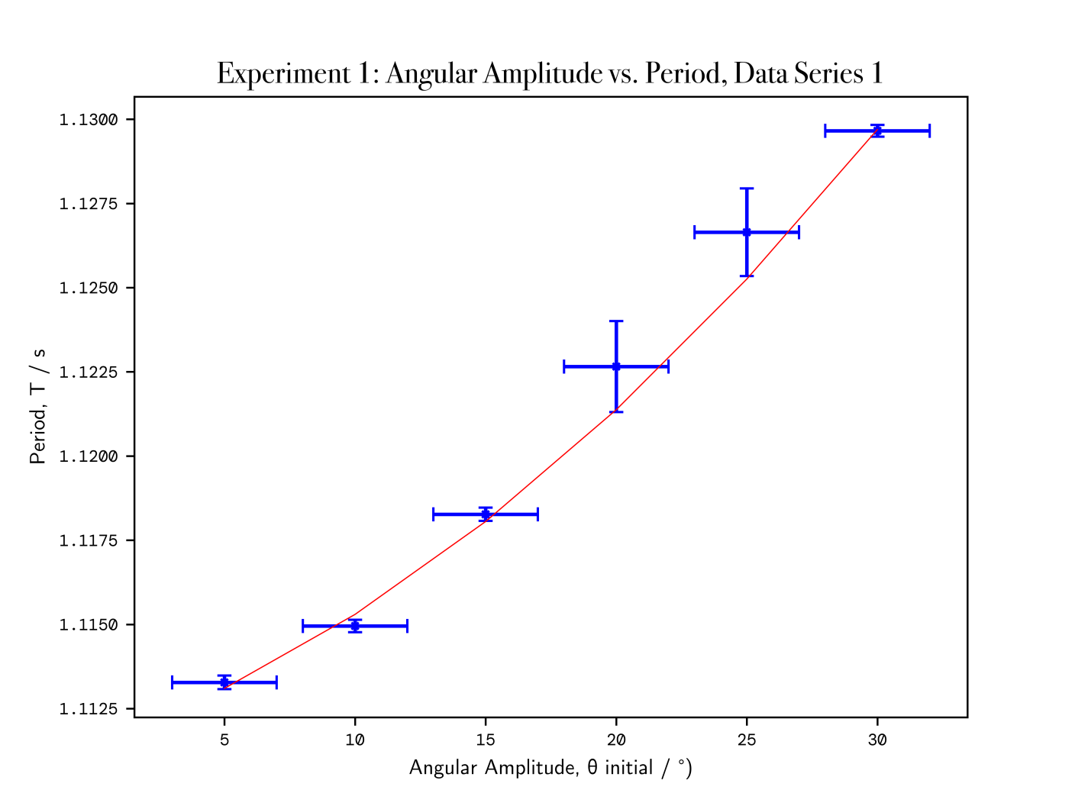

**Figure 8:** The final summary plot for Data Series 1. As can be seen above, there exists large uncertainty in the angular amplitude for each value, which we attributed to the resolution of the protractor, as well as the evident parallax error that occurred.

**N.B:** the scale on the y-axis is very minute in the above plot, so error bars appears to gargantuan, when in reality represent far smaller error. Note the larger y-axis error bars in the 20° and 25° angular displacement can be clearly seen from the profile plots we obtained, and the subsequent curve-fits we then got. The deviation from the sinusoidal behaviour was incorporated into the curve-fitting process and results in the much larger uncertainties.

Compare and contrast the following data presented in Figure 9, and Figure 10.

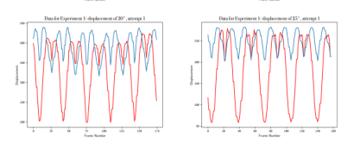

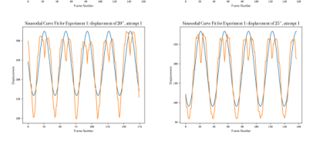

**Figure 9:** The respective profile plots and curve fits of 20° (left), and 25° (right). Note the only quantity that the curve fit is interested in measuring or quantifying is the time period of the fitted sinusodial wave, of which it does a good job of.

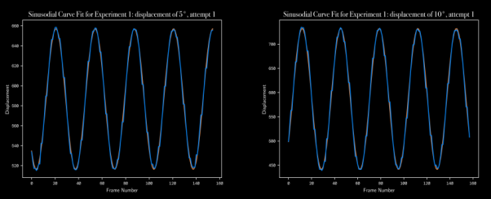

**Figure 10:** The curve fit of 5° (left), and 10° (right)., which follows far more tightly.

|  |
| --- |
| **Experiment A, Data Series I**  T₀ = 1.11E0 ± 4.11E-4 seconds  *Constants*  α = 2.44E-4 ± 5.15E-5  β = 1.01E-5 ± 1.37E-6 |

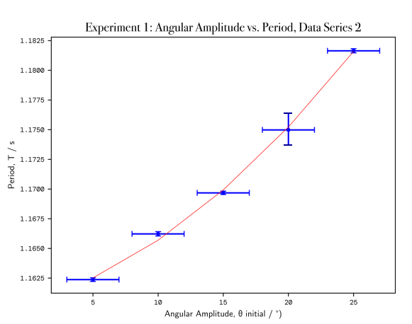

**Figure 11:** The final summary plot for Data Series 2, of Angular Amplitude against Period. As can be seen above, a larger uncertainty was found in the period for the angular amplitude of 20°. This is due to similar reasons as described in Data Series 1.

|  |
| --- |
| **Experiment A, Data Series II**  T₀ = 1.16E0 ± 3.47E-4 seconds  *Constants*  α = 2.72E-4 ± 4.63E-5  β = 1.83E-5 ± 1.50E-6 |

As can be seen, our data for both data series are in accordance with each other for T₀, and both find our values of dimensionless constants to be very small, almost at zero. This agrees with our prediction.

**[ADDITION:]**

**Upon further research, we found that the value of α and β should in fact be 0 and 1/16 respectively, as per the Power Series solution to the Elliptical Integral. It stands to reason that our values are similarly small for these calculations, but both values fall outside the uncertainty ranges of our constants.**

In Experiment B, we are given the following relation:

**Equation 6:** the time period is given by the following relation, where generally the ratio of the inertial mass to the gravitational mass is 1. However treating tmasses as different variables yields the above equation.

It is then assumed that any differences between the bob’s inertial and gravitational mass are due to the density of the material, ρ. We represent this expression for density as and we would expect this relation to be have some element of proportionality. Rearranging this new expression to obtain the value of dimensionless constant k, we find that:

Consequently, we can also test how well our experiment went by comparing this theoretical value of the y-intercept, with what we obtained experimentally. The mean of all our attempts, and their resultant uncertainty, can be found presented in **Figure 12**.

The resultant uncertainties were calculated using the uncertainties package, which handily took care of all the calculations with its “ufloat” data types:

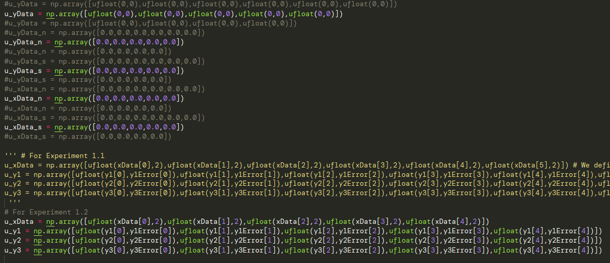

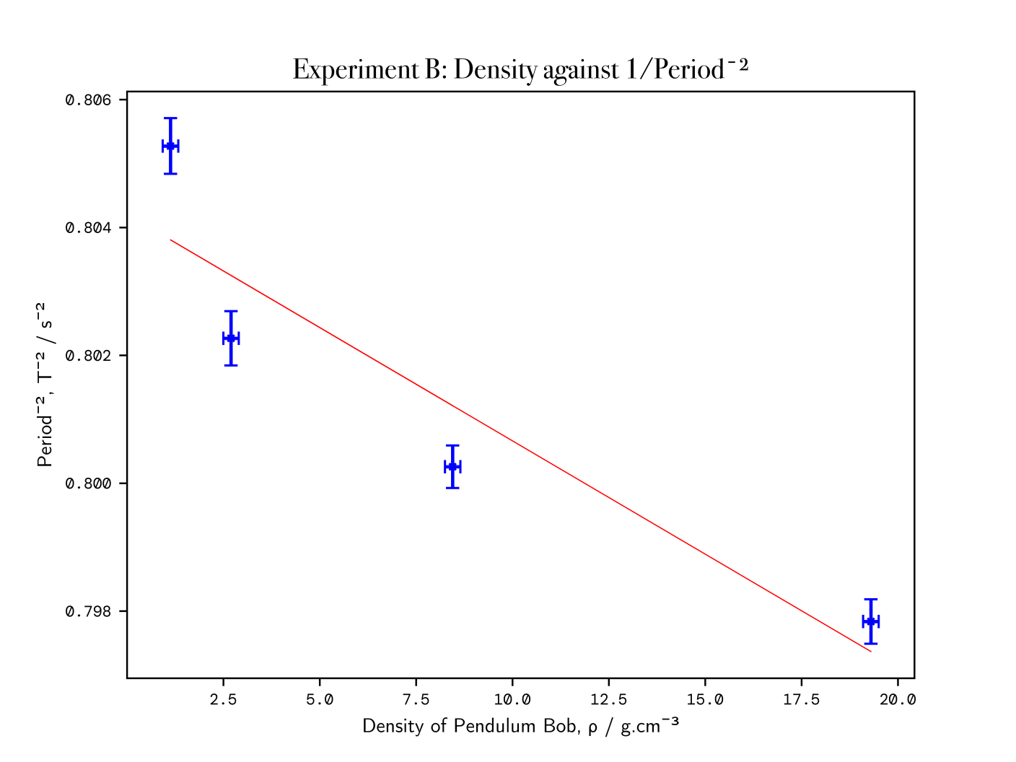

**Figure 11:** The final summary plot for Experiment 2, exploring the effect of materials of various densities on the period of the pendulum. As can be seen above, whilst none of the points intercept the line of best fit, there are an equal number of points above and below.

|  |
| --- |
| **Experiment B**  theoretical y-intercept: g/(4π²·0.3) = 0.828 ± 0.036  experimental y-intercept: 0.804 ± 1.09E-3  gradient = -3.54366488e-04  *Constants*  k = -4.28E-4 ± 1.02E-4 |

Our theoretical and experimental y-intercepts lie in each other’s ranges, suggesting the experiment went sufficiently well, with a percentage error of less than 3%. From our gradient, which we obtained from the curve fit, we obtained our constant k to be of the order of magnitude ×10¯⁴, which is very small, and agrees with our prediction.

Summary

Consequently, we obtained from the first of the pendulum experiments, that through the observation of the period of pendulum oscillations, and taking note of their initial angular displacements from the maxima, we could collate the average of all our recordings onto a plot and propagate their uncertainties computationally. Using these final plots, we were able to obtain values for the dimensionless constants α = (2.44 ± 0.52)×10-5 and β = (1.01 ± 0.14)×10-6 from our first series of data; whereas we obtained from our second series of data, that α = (2.72 ± 0.46)×10-5 and β = (1.83 ± 0.15)× 10-6.

The slight difference in our results from the two series of data stemmed in part from the differing methodologies we applied to both series of data; the second series of data employed a much improved method, which ought to have yielded more accurate results. Through the large volume of recordings we took for each angular displacement, we were able to reduce the percentage uncertainty of the period at each angular displacement to less than 1%.

In the second of our pendulum experiments, we repeated the procedure of experiment 1 at a common starting angular displacement, for identically-sized pendulum bobs made from materials of differing densities: tungsten, brass, aluminium and nylon. Again, taking the average over several videos, and attempting to reduce systematic errors in the experiment, then collating this data in a linear plot, we arrived at our value of constant k to be (-4.28 ± 1.02)×10-4. We found our theoretical y-intercept value to lie very closely to our actual value obtained in the experiment. In order to minimise the very large uncertainties in our obtained values, (in Experiment B for the gradient, our propagated uncertainty came out larger than the value itself!), we would have to take readings over a larger selection of materials of differing densities, and record a larger number of videos than the mere 12 we took for this experiment.

The obvious improvements to make to this experiment to further bound the value of k, as well as our constant α and β, and obtain more precise and accurate data would be the use of better equipment. A camera with a higher frame rate, such as 120fps, are now widely available in mobile smartphones such as the iPhone 13 Pro Max, and would also have a larger screen resolution than the provided 720p. This would greatly decrease the uncertainties associated with the curve fits. Another improvement would be the use of a chroma key when recording the videos - if each pendulum bob were denoted in a colour, such a green, on camera, and then processed through a chroma key filter, this would make the tracking of the pendulum more accurate - for instance, initially, we were concerned that the black background we were given had a few lighter coloured marks and that this would interfere with its tracking (we attempted to resolve this through cropping the videos even further in FFMPEG).